* Windows Manager Tweaks测试

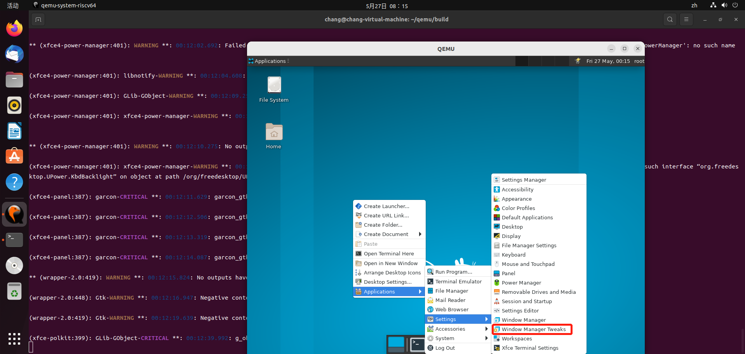

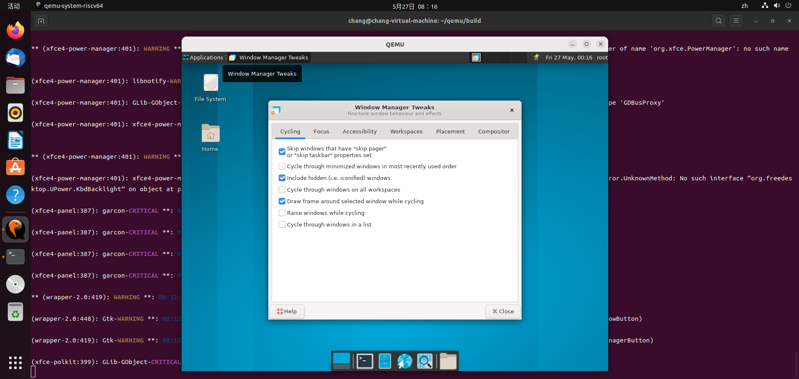

* Windows Manager Tweaks-Focus页面跳转正常

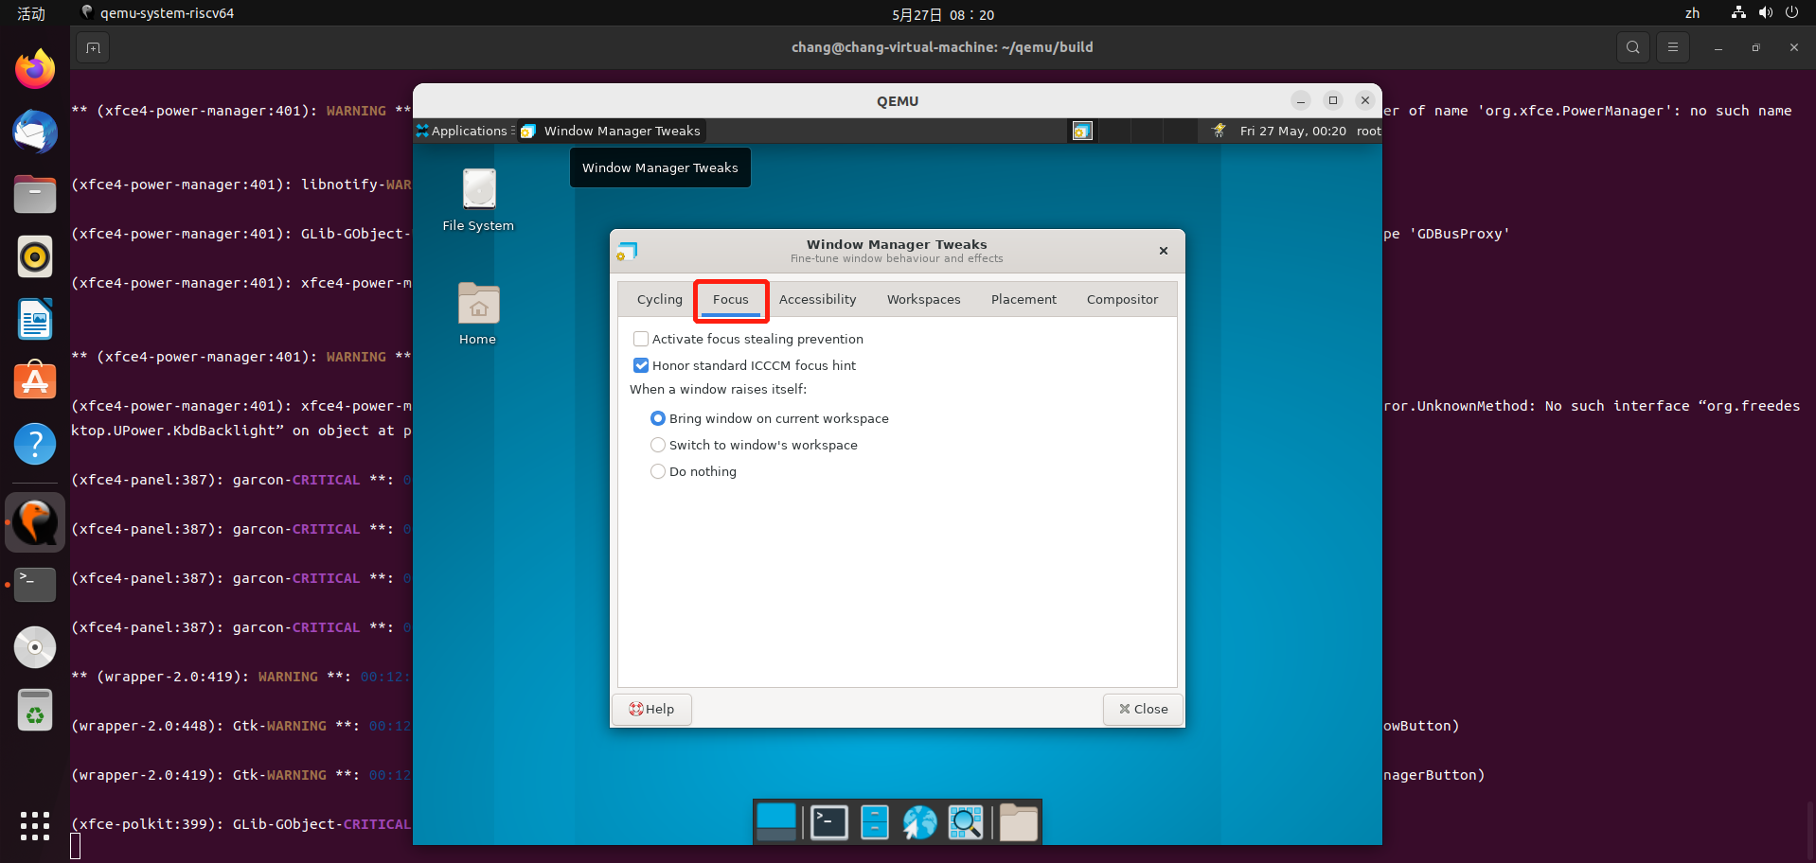

* Windows Manager Tweaks-Accessibility页面跳转正常

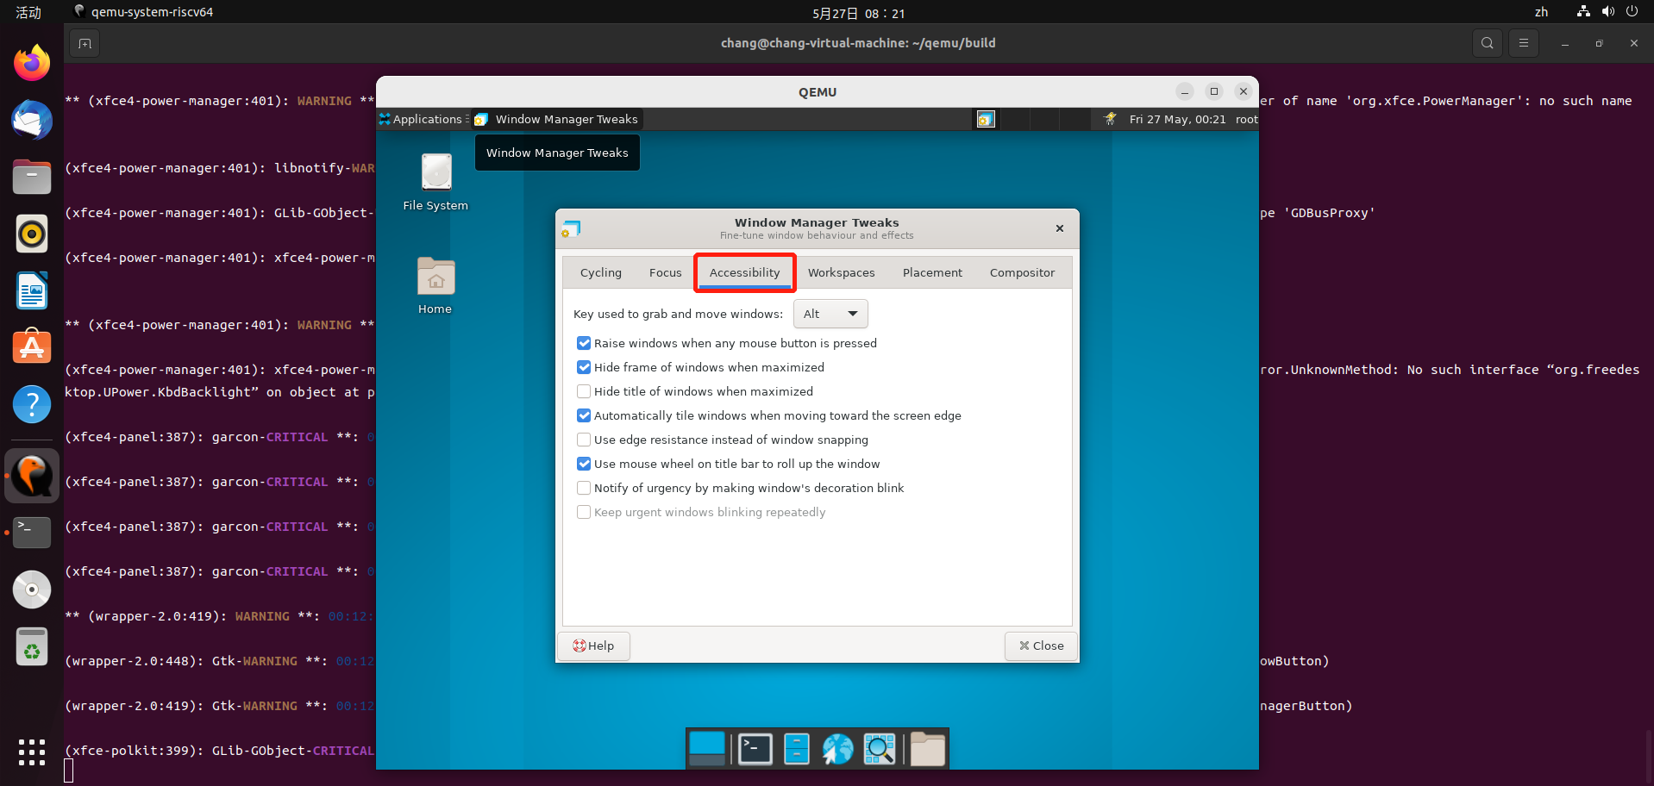

* Windows Manager Tweaks-Workspaces页面跳转正常

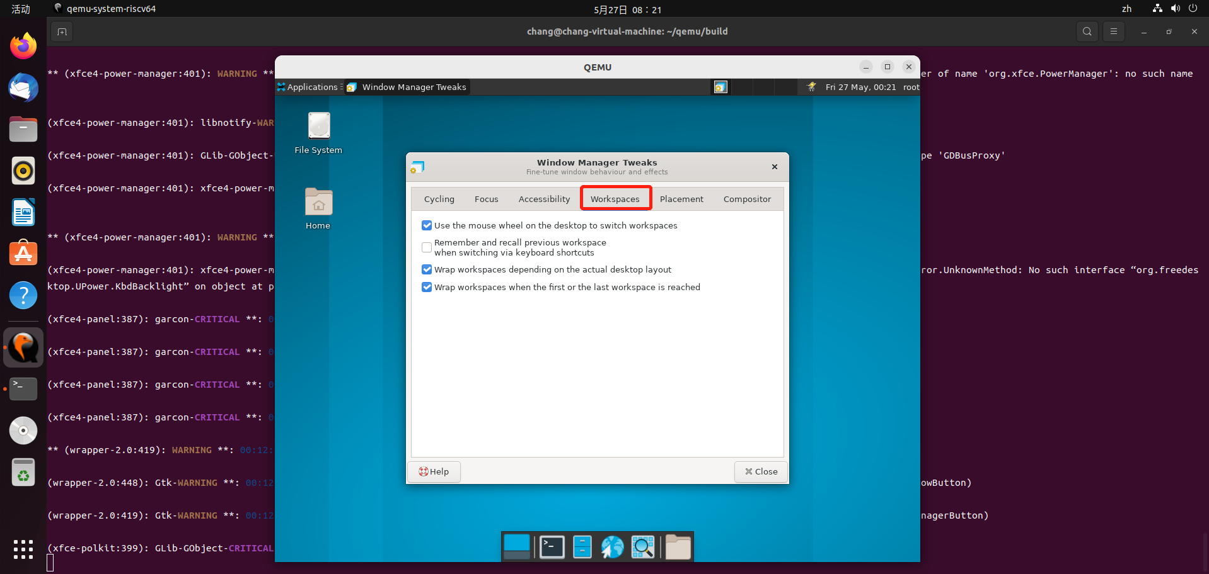

* Windows Manager Tweaks-Placement页面跳转正常

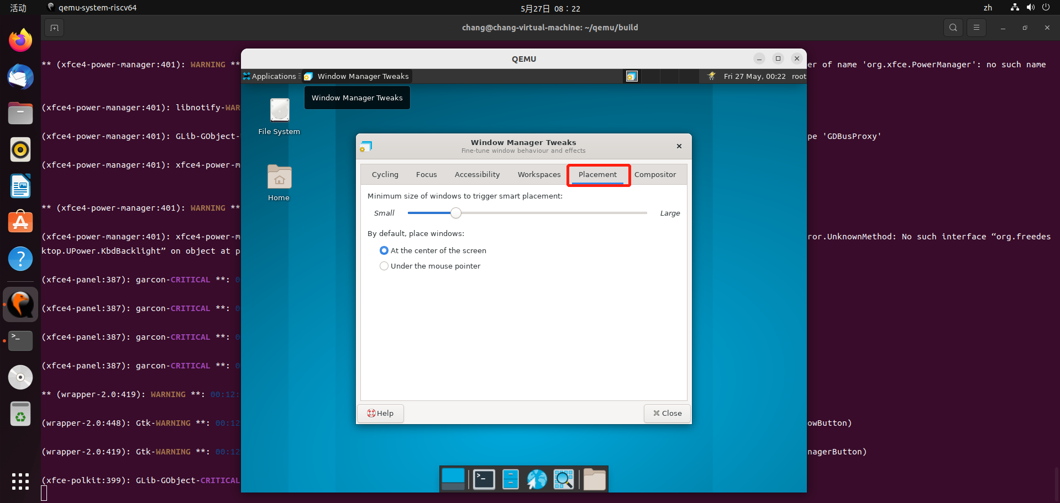

* Windows Manager Tweaks-Compositor页面跳转正常

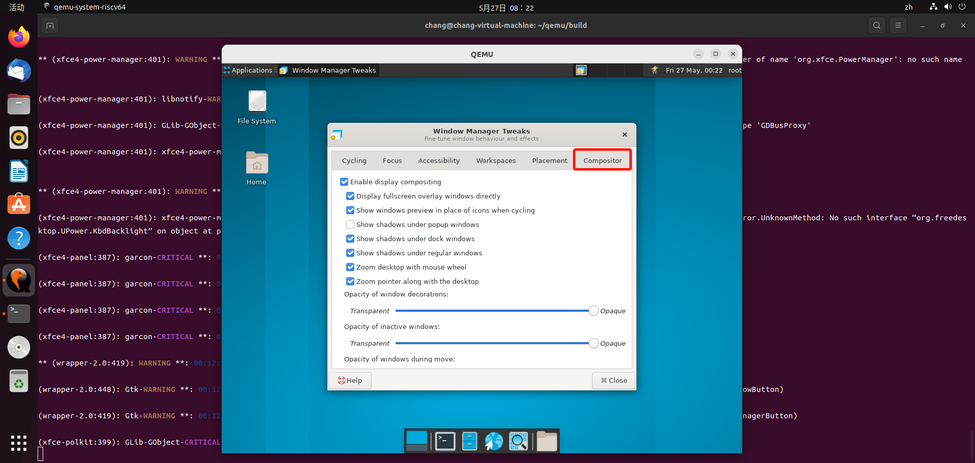

* Windows Manager Tweaks-Cycling页面跳转正常

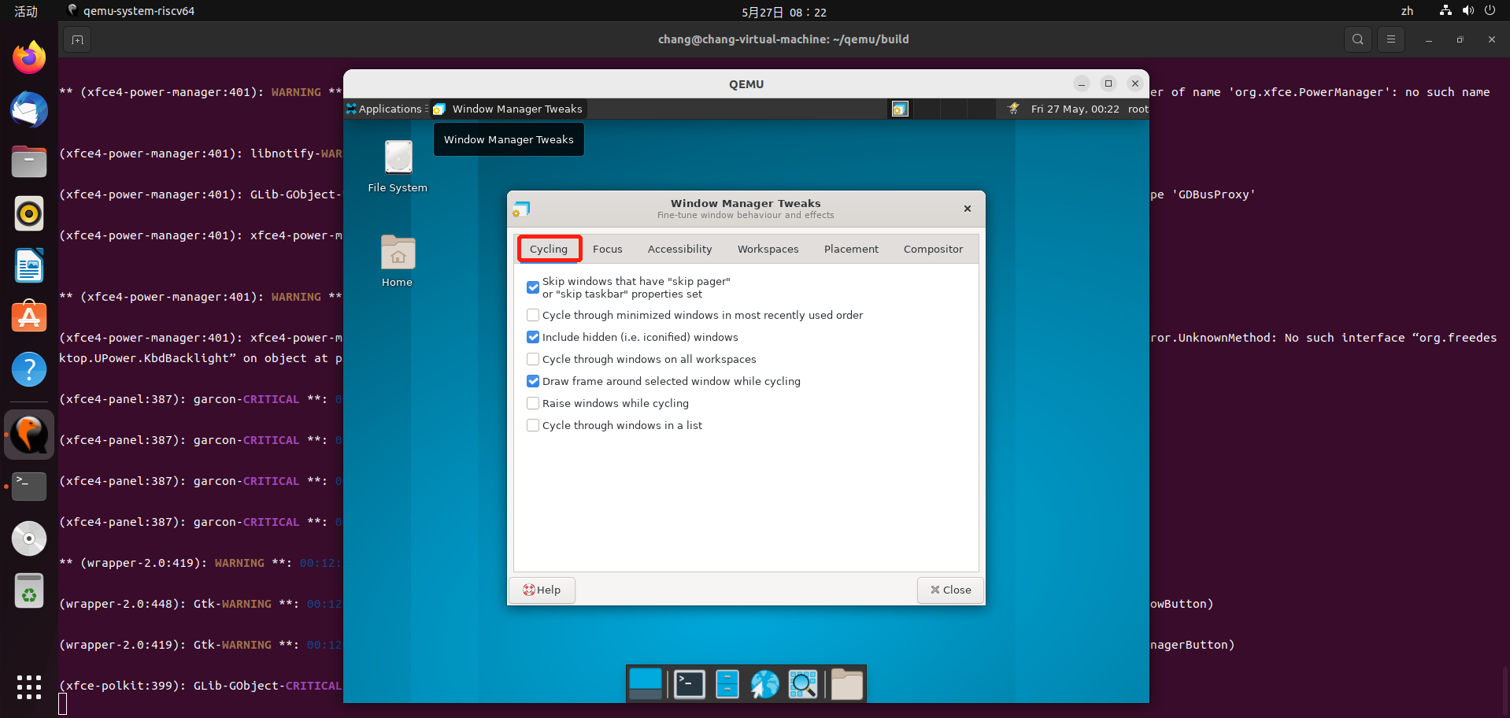

* Windows Manager Tweaks-Cycling页面勾选功能正常

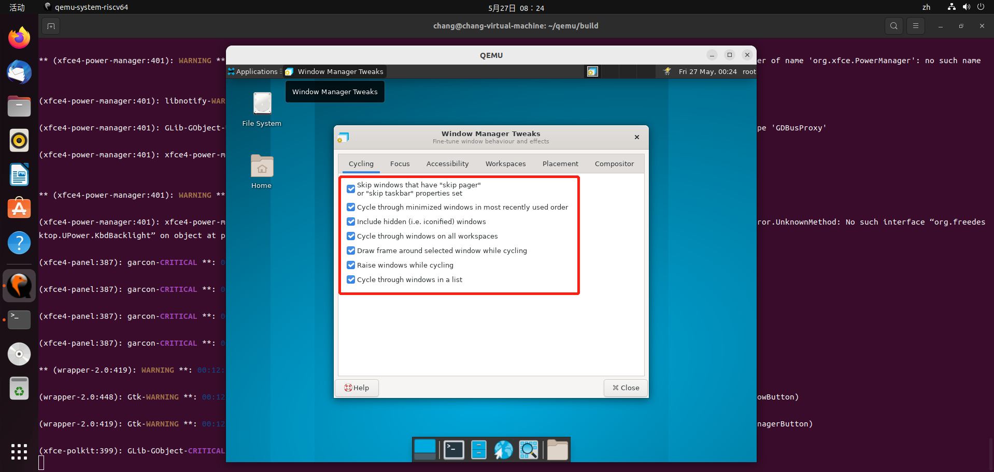

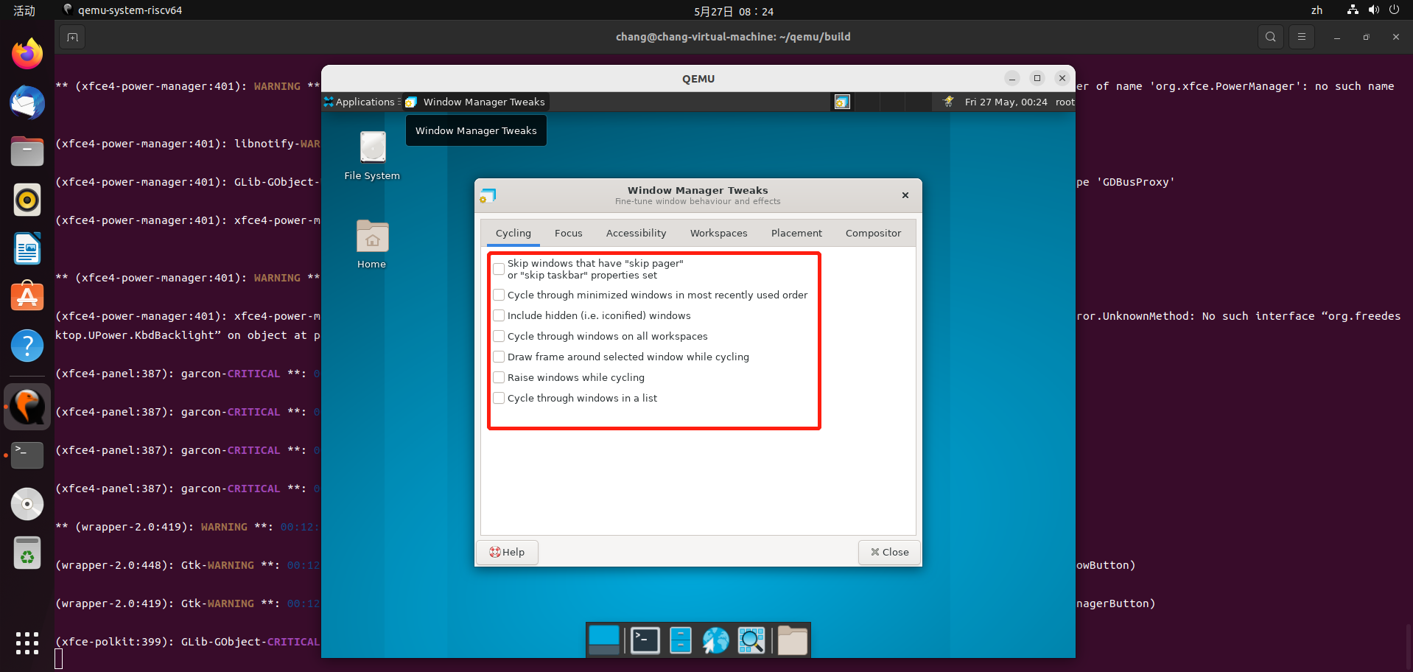

* Windows Manager Tweaks-Focus页面勾选功能正常

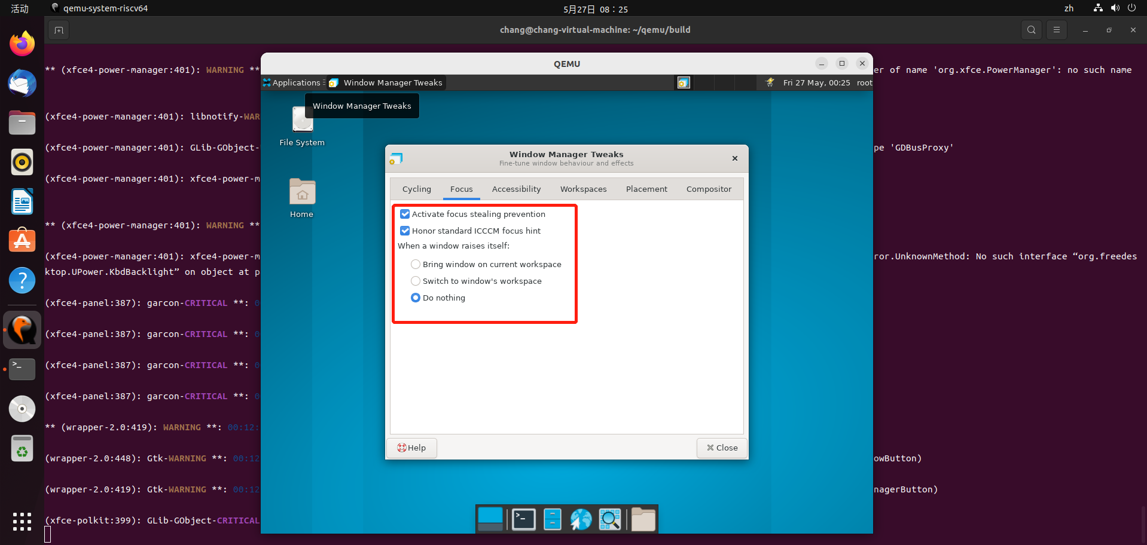

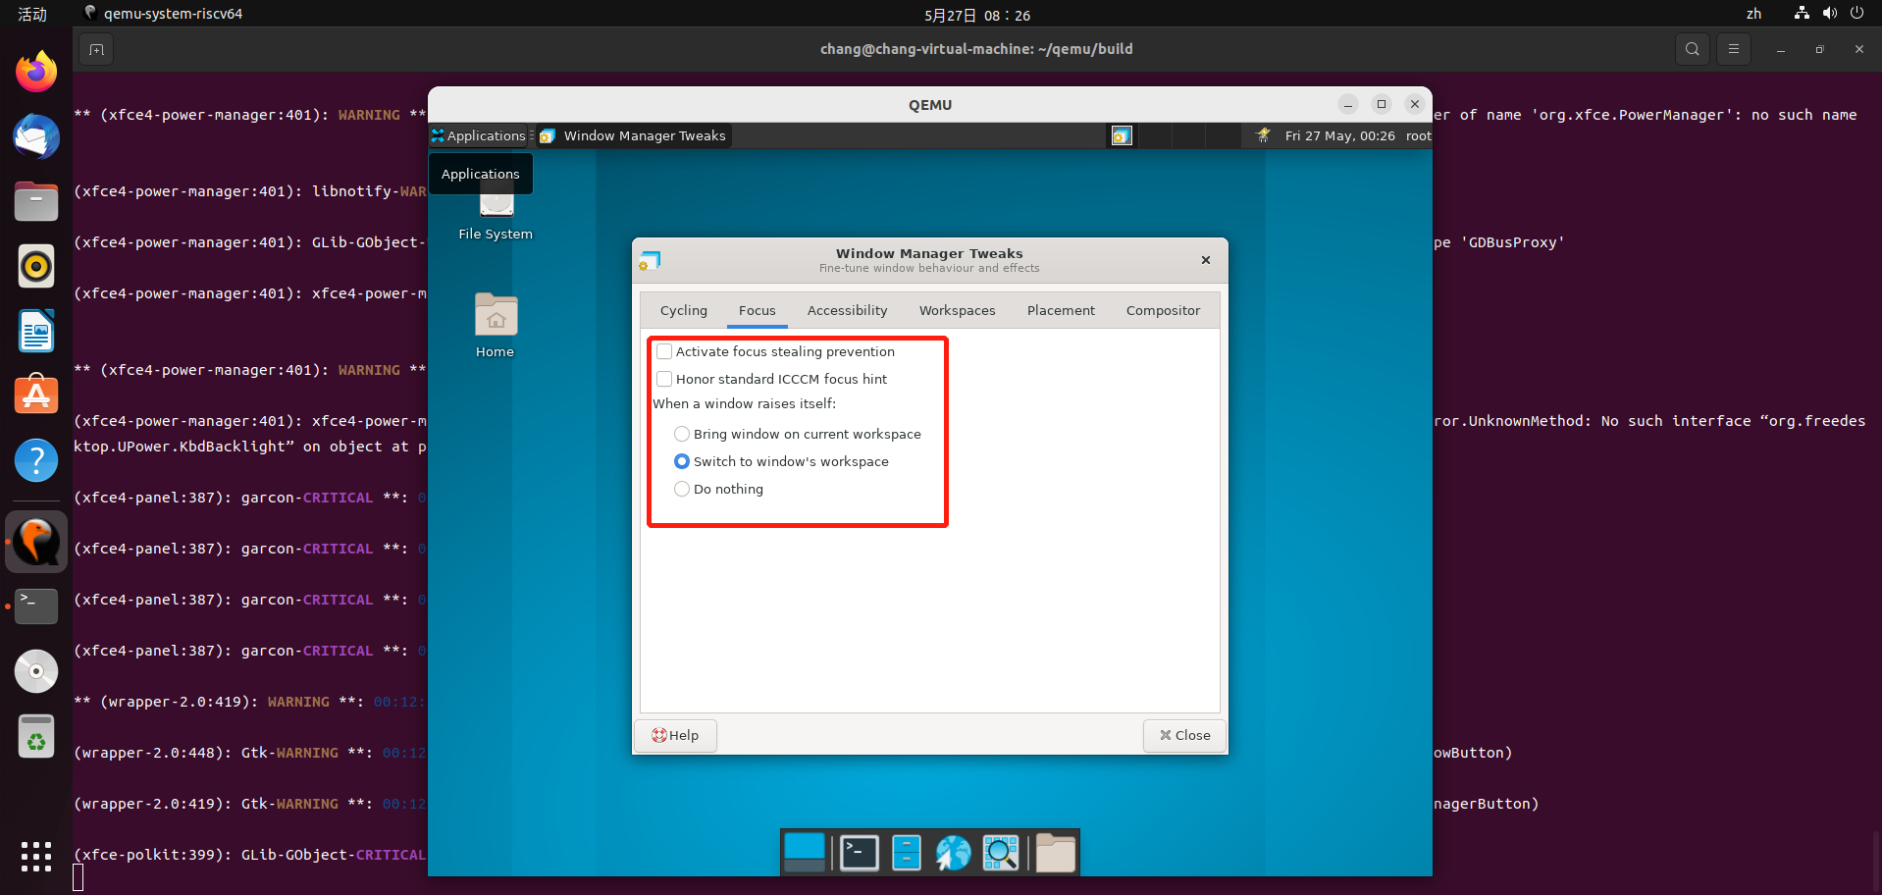

* Windows Manager Tweaks-Accessibility页面勾选功能正常

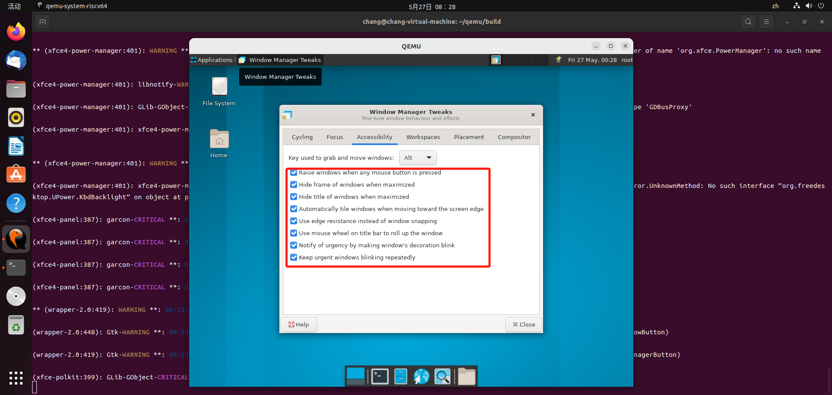

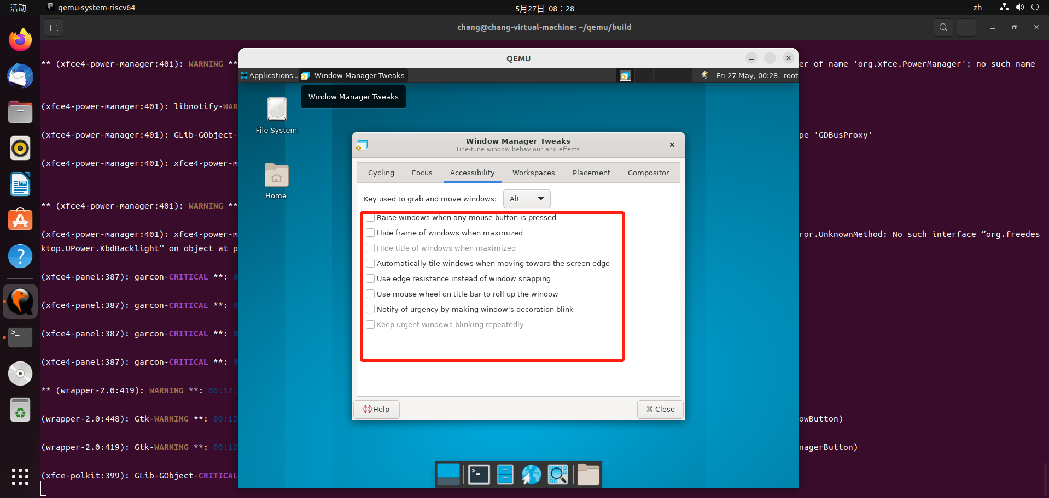

* Windows Manager Tweaks-Accessibility下Key used to grab and move windows选择功能正常

（举其中一例）

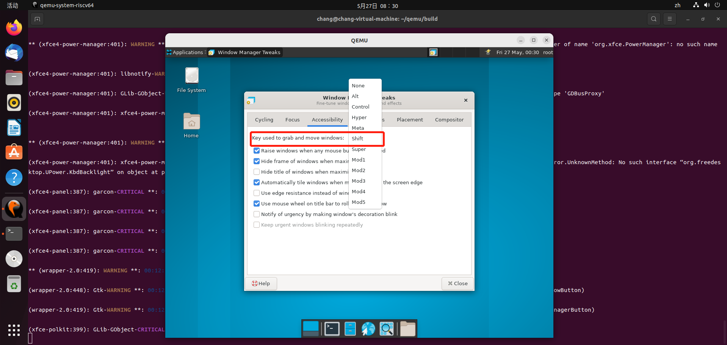

* Windows Manager Tweaks-Workspaces页面勾选功能正常

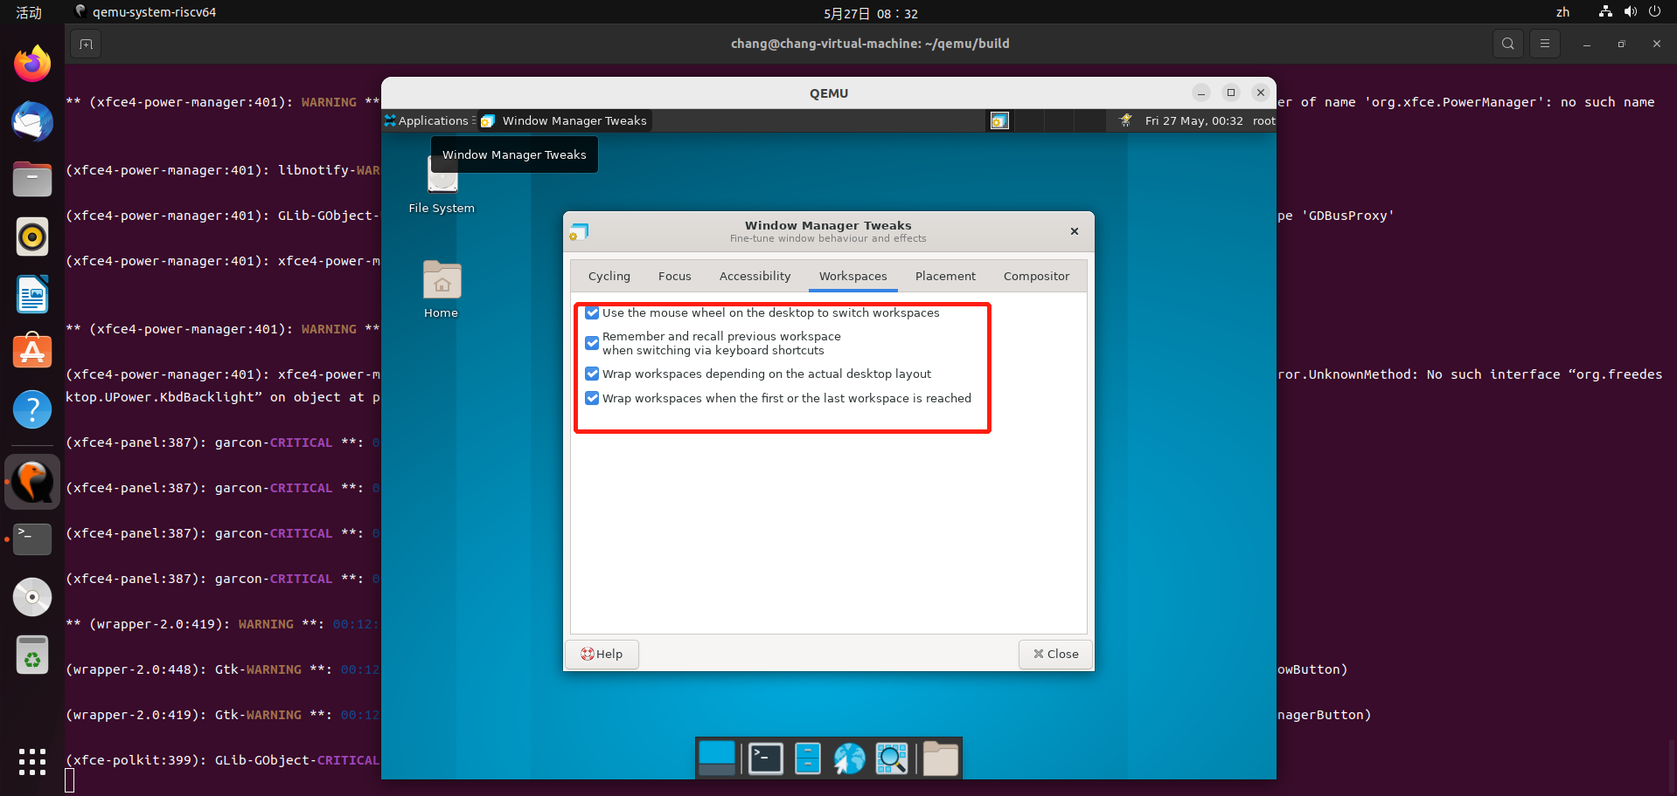

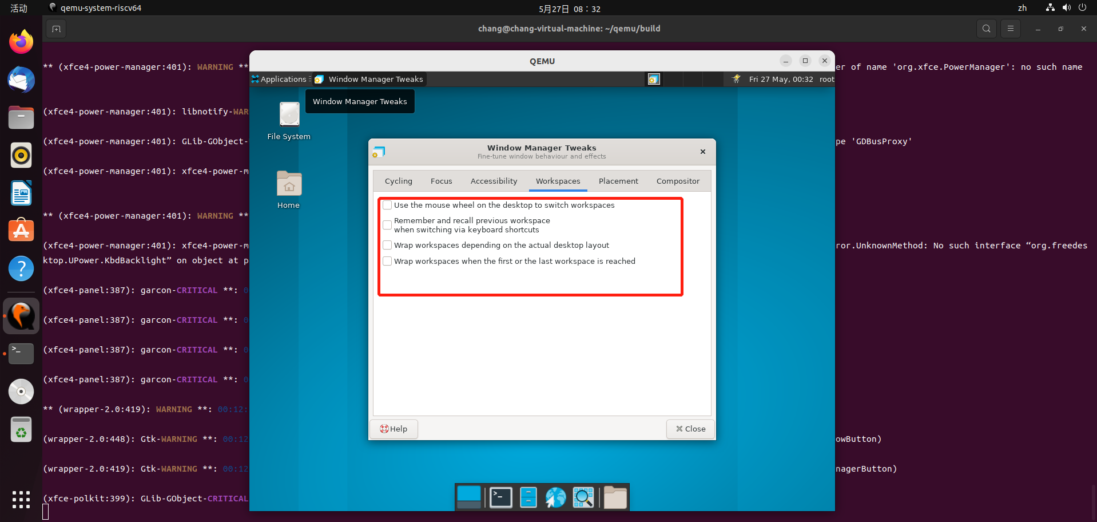

* Windows Manager Tweaks-Placement-Minimum size of windows to trigger smart placement测试，进度条拖动测试正常

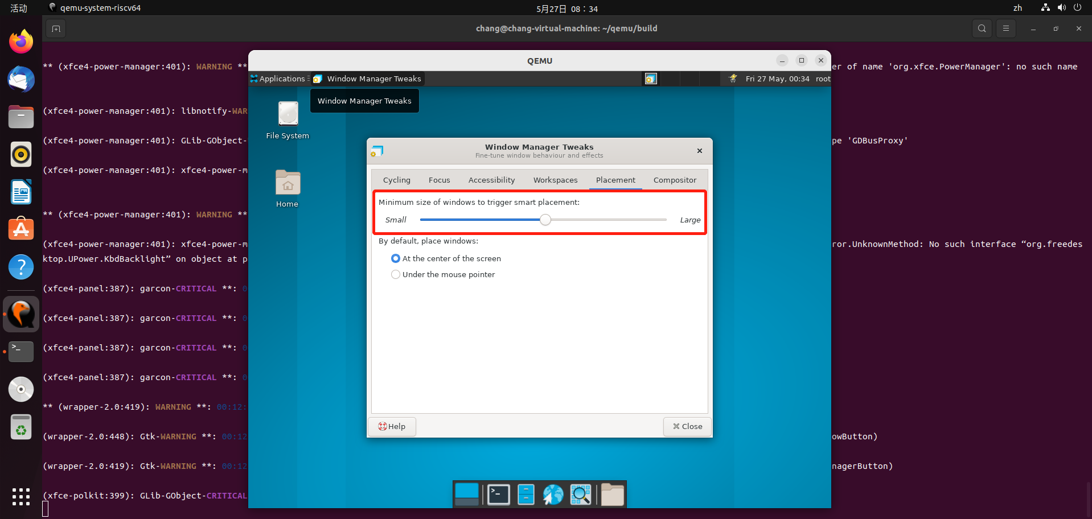

* Windows Manager-Tweaks-Placement-By default，place windows：勾选测试正常

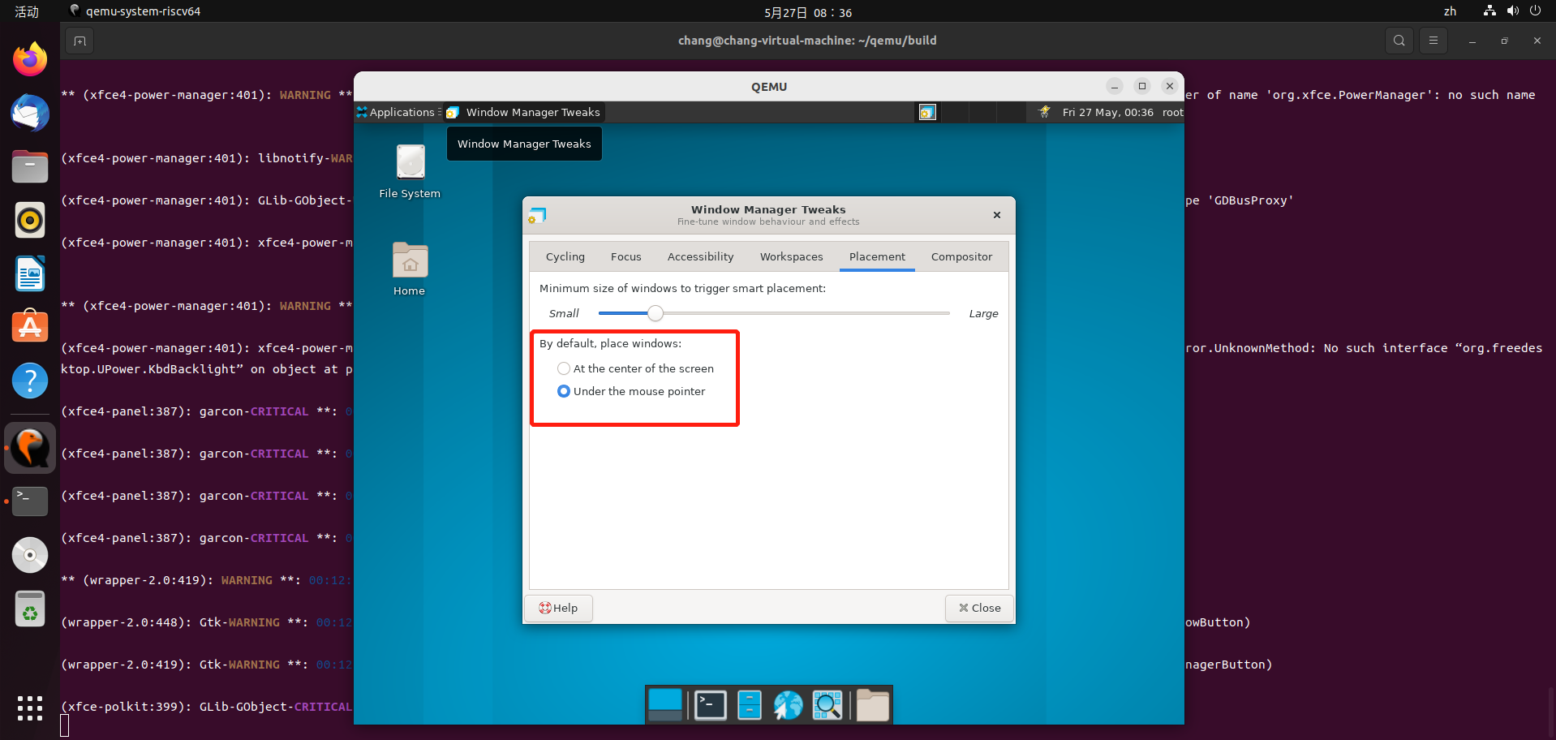

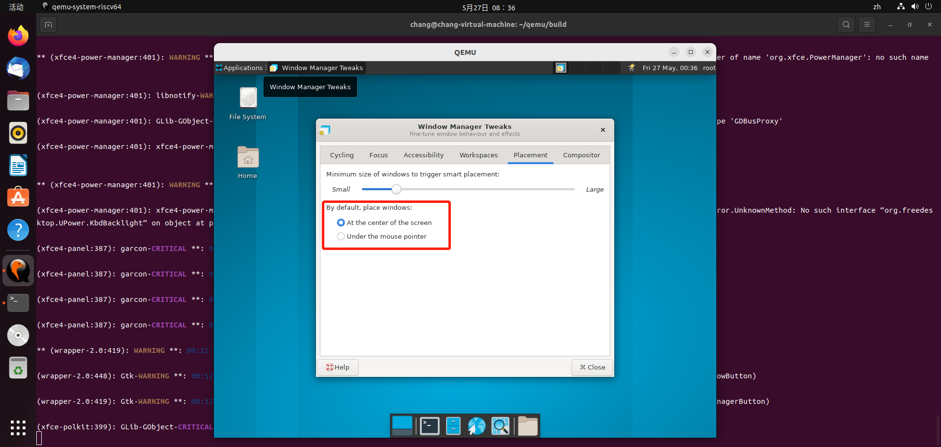

* Windows Manager Tweaks-Compositor页面勾选功能正常

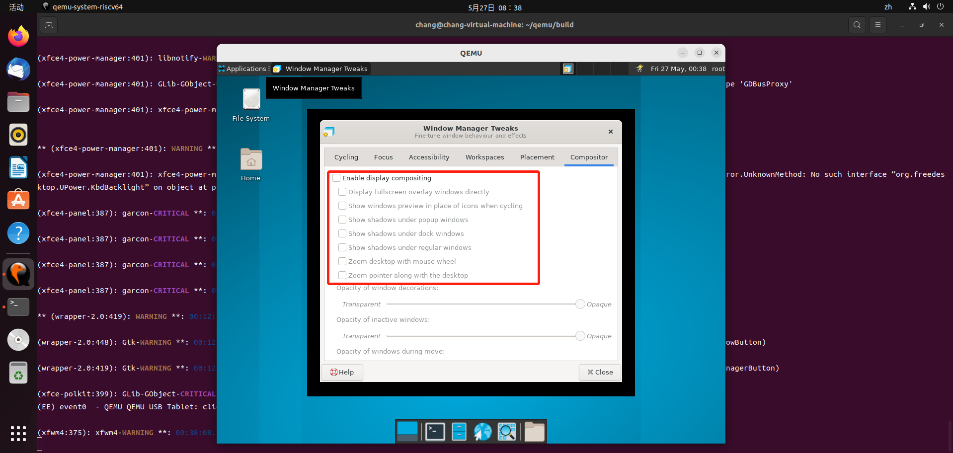

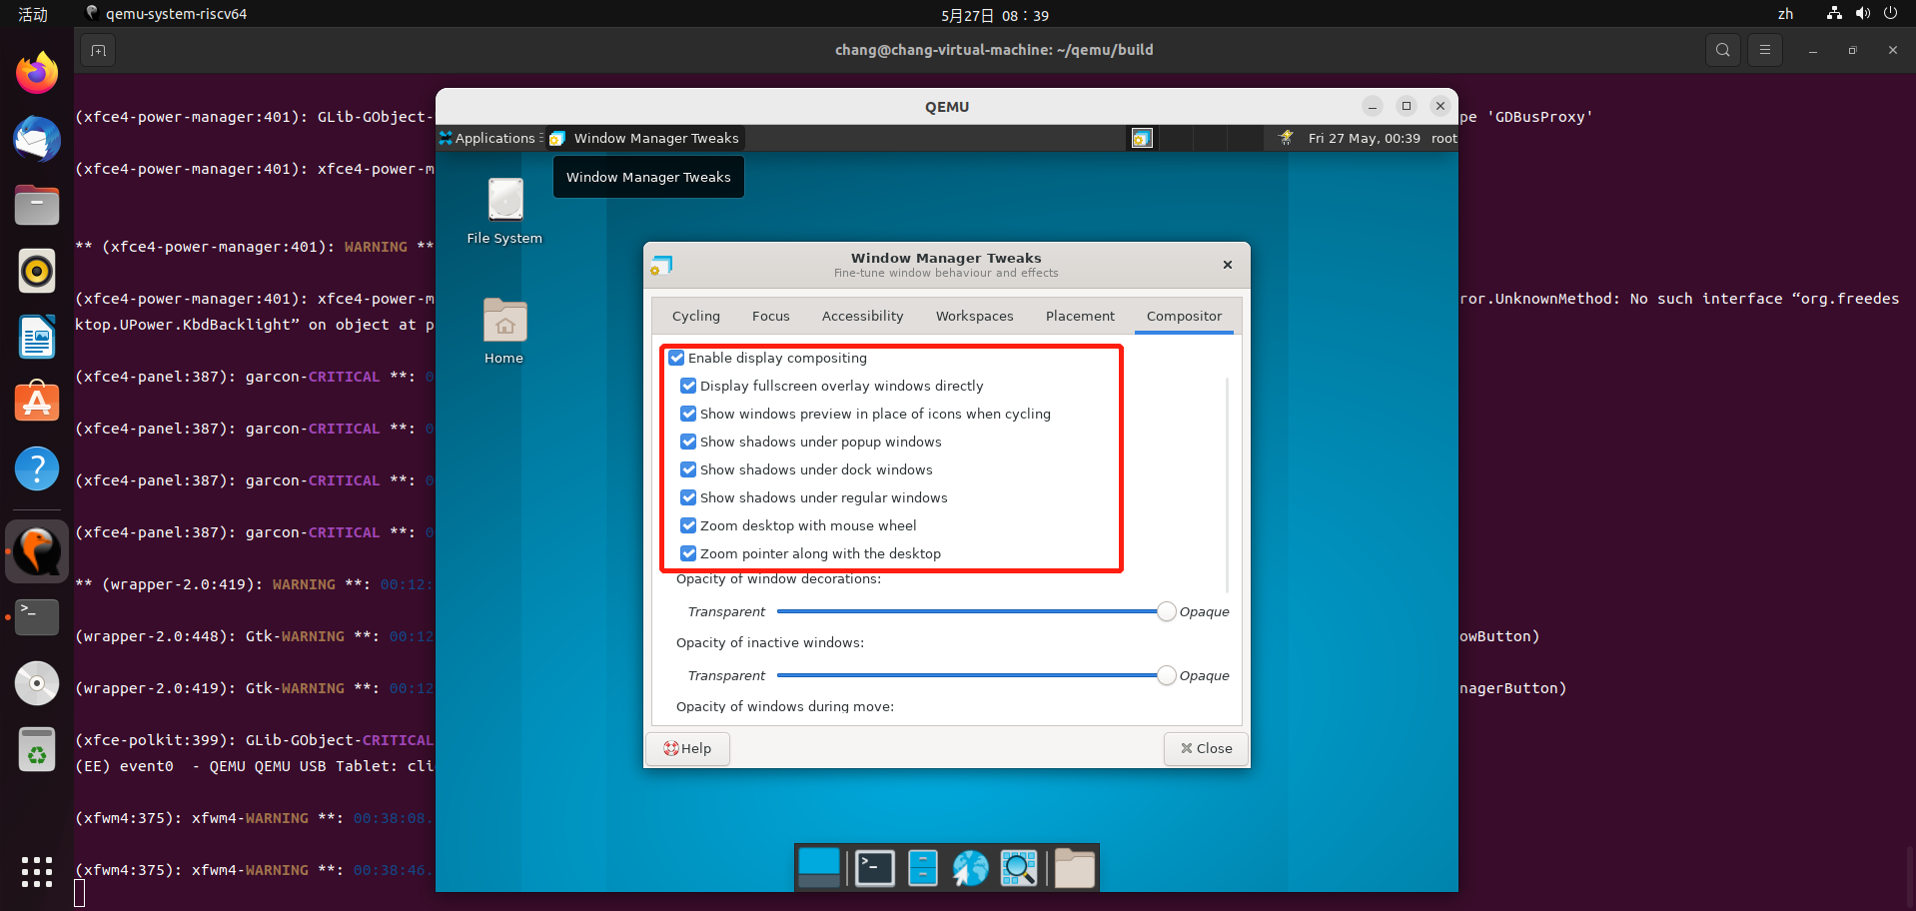

* Windows Manager-Compositor下的Opacity of window decorations/Opacity of inactive/Opacity of windows during move/Opacity of windows during resize/Opacity of popup windows进度条拖动正常

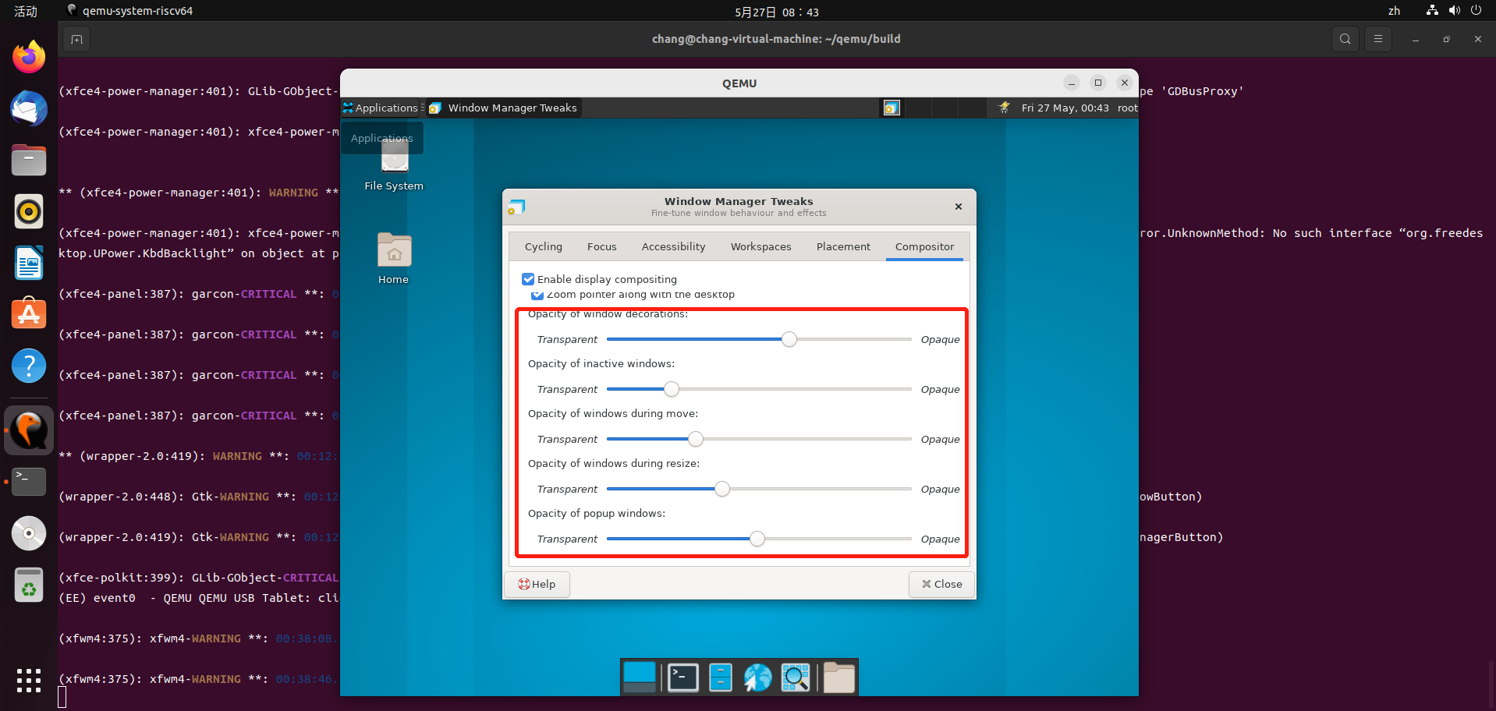

* Windows Manager Tweaks-Help测试功能正常

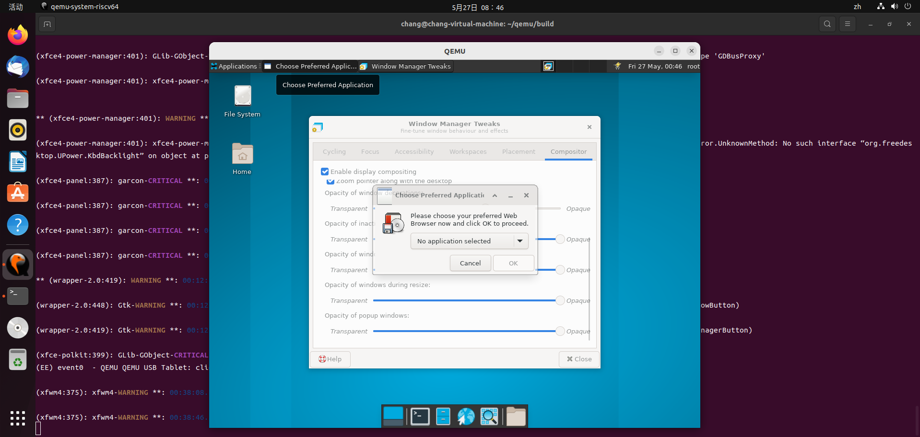

* Windows Manager Tweaks-Close测试功能正常
* Workspaces测试

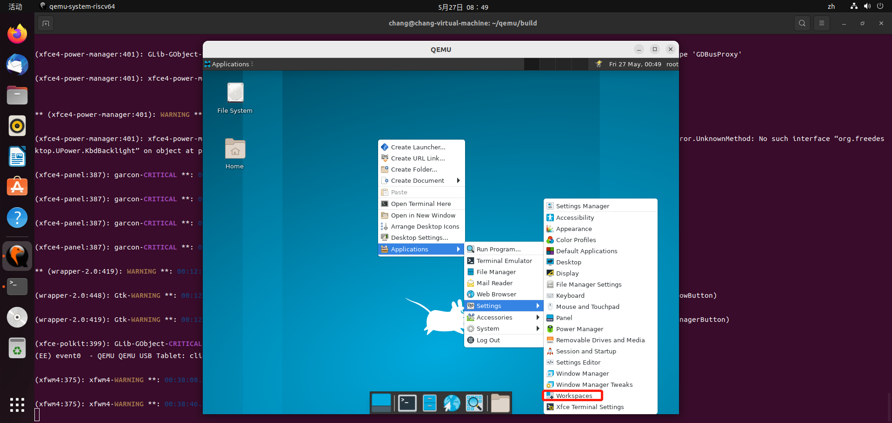

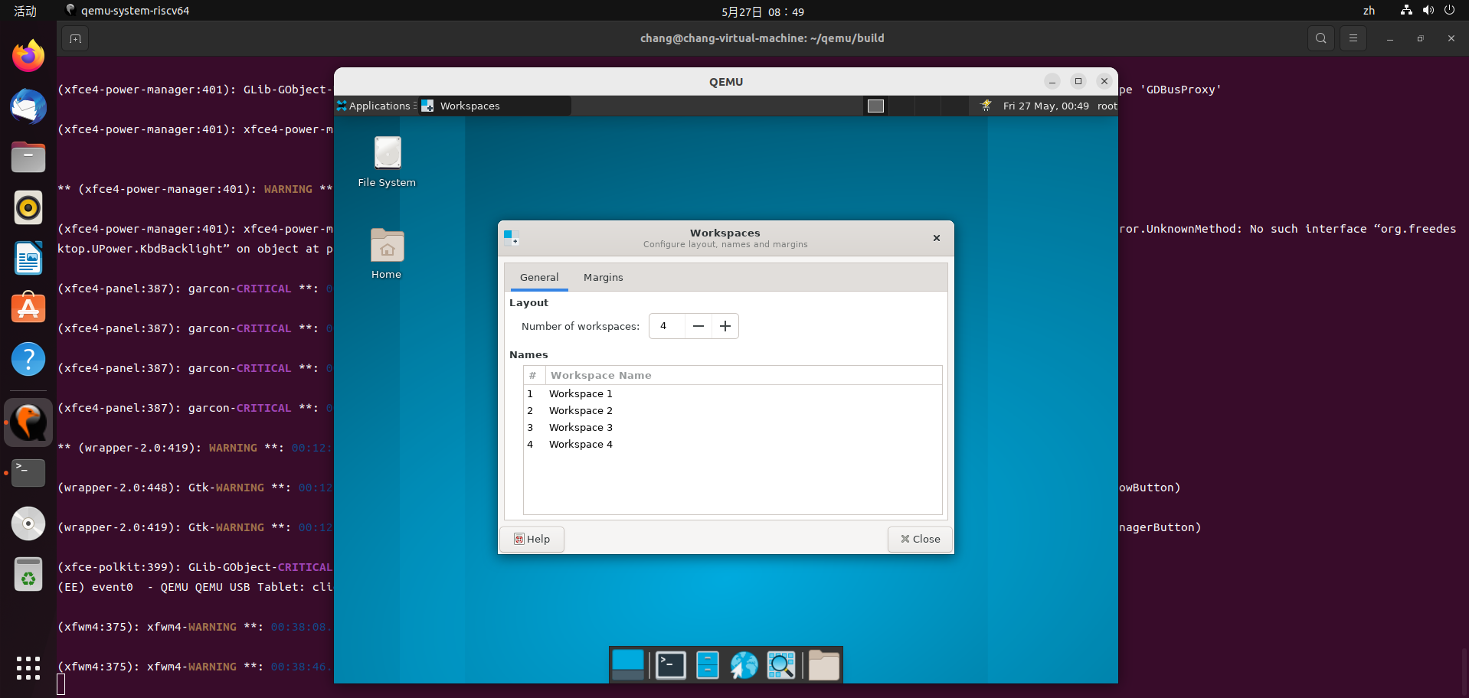

* Workspaces-Margin、Genera页面跳转正常

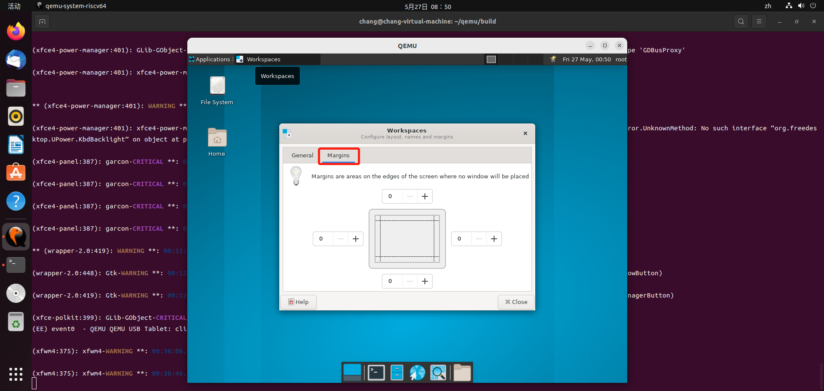

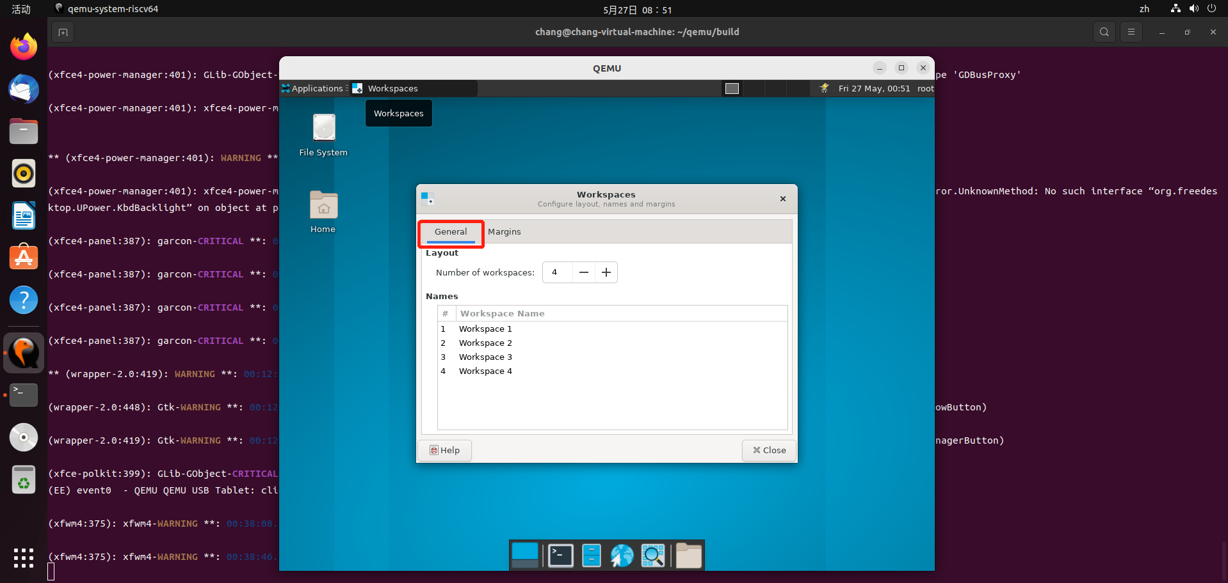

* Workspace-Genera-Layout功能测试

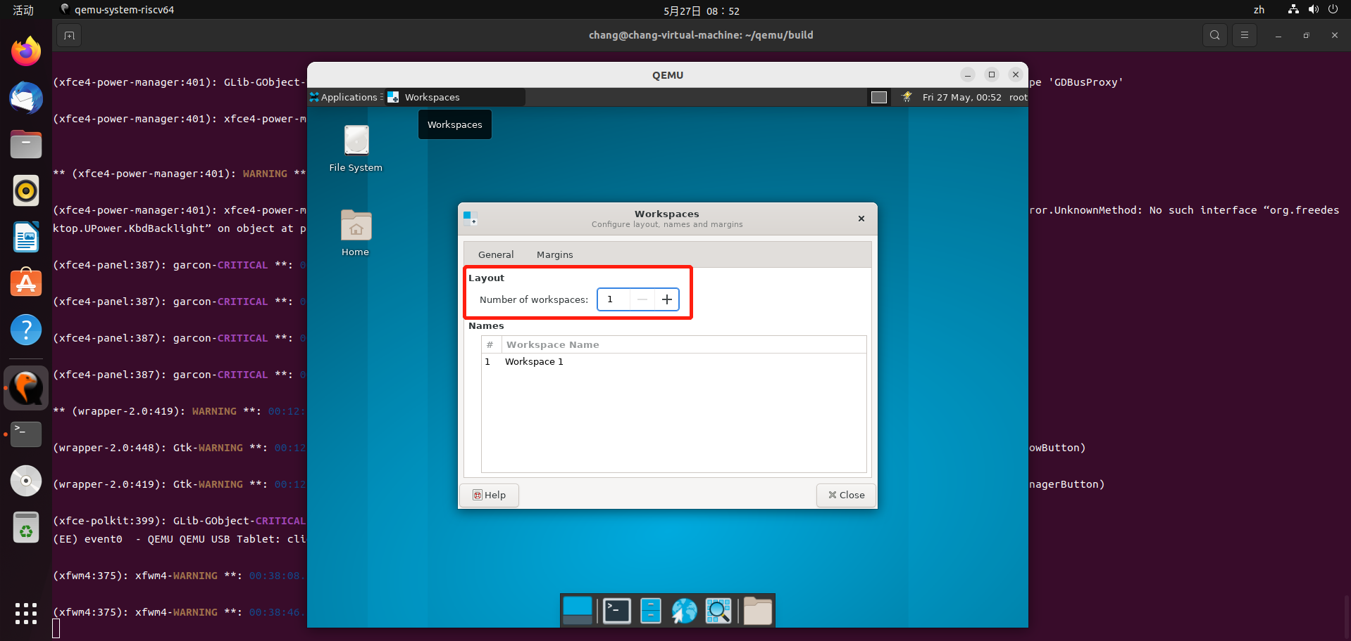

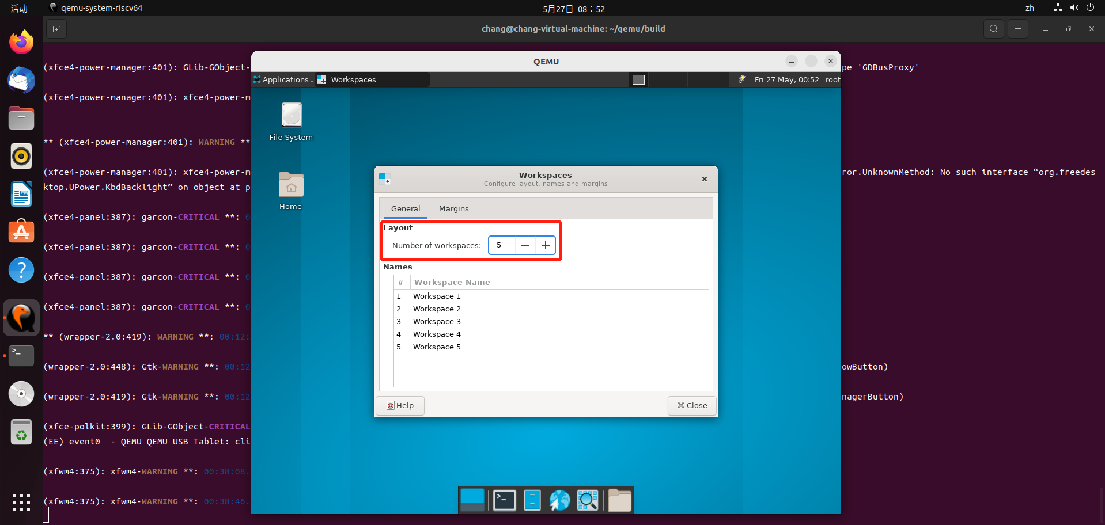

* Workspace-Genera-Margin功能测试不通过：仅支持两位及以下的数值输入

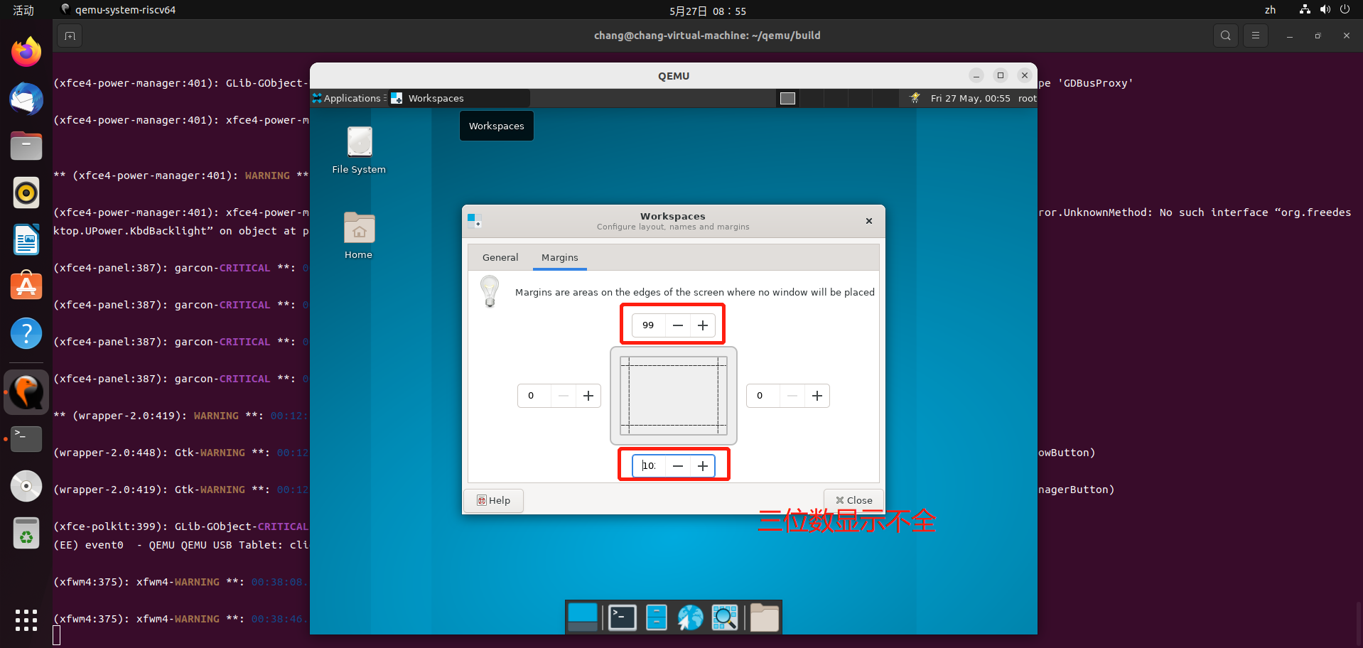

* Color Profiles启动测试通过

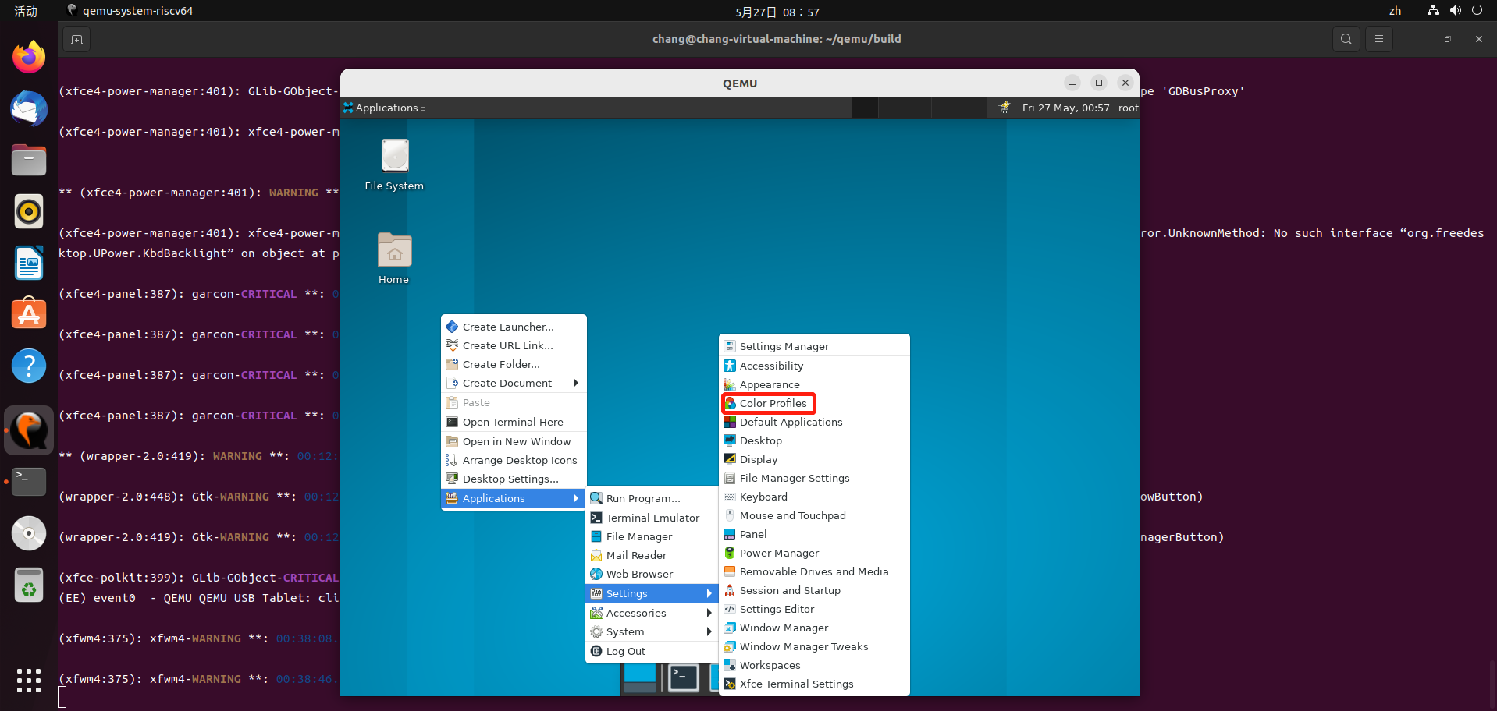

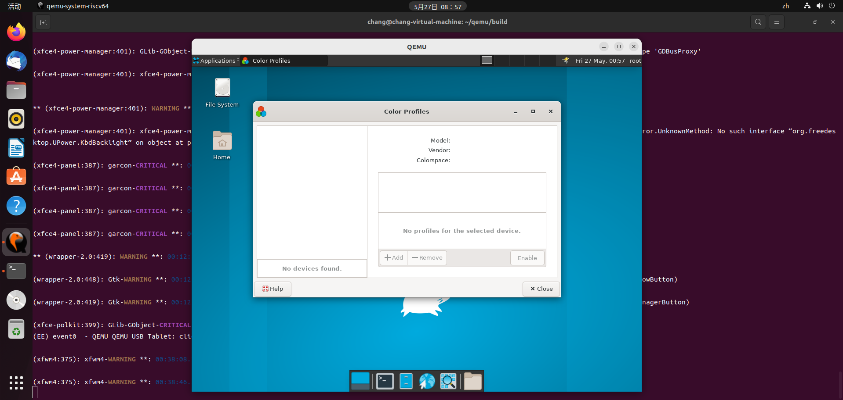

* Color Profiles-Help启动测试通过

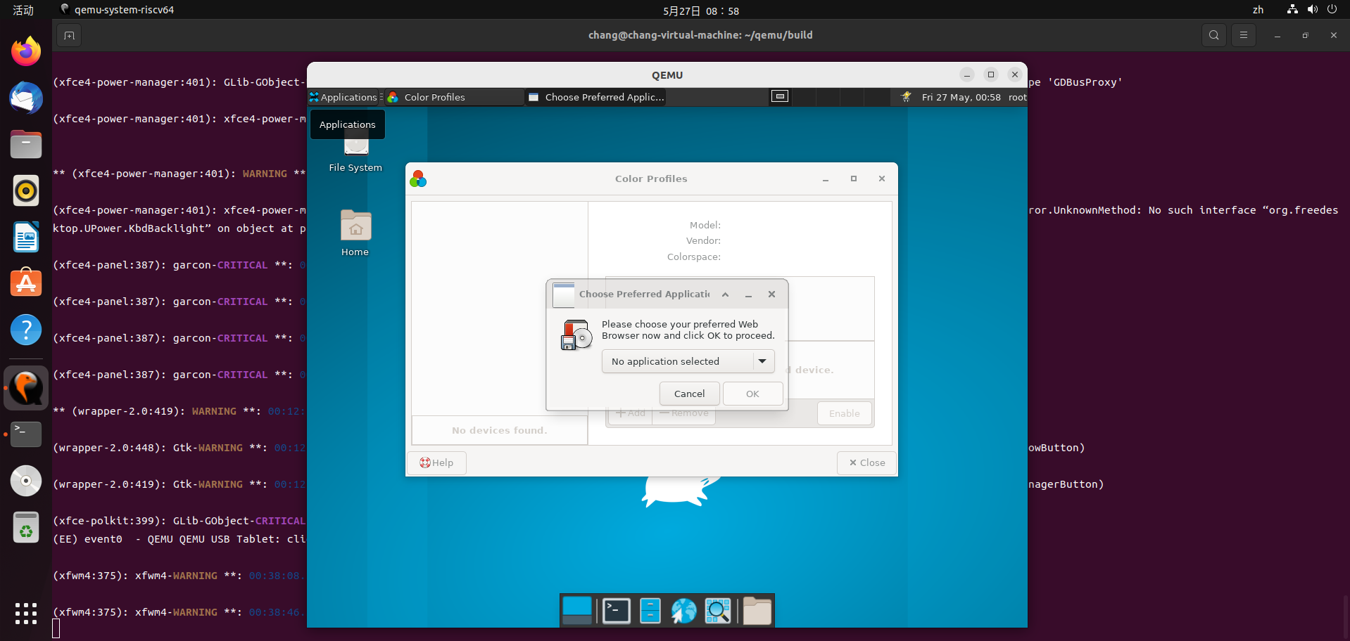

* Color Profiles-Close启动测试通过